South East Technological University,

Waterford



Semester 2: Project Implementation

Promotional Tool-Kit for a Musician

_________________________________________

Author: Supervisor:

Jake Dunphy O’Leary Brenda O’Neill

Student Number: 20101923

Course: BSC. In Creative Computing

Thursday, January 29, 2026



“Nothing really matters, but it matters if it matters to you”

Carly Rae Jepsen, Kollage. (Jepsen, C.R., 2023)

South East Technological University, Waterford

Abstract
The project provides information, instructions, and examples of a digital promotional tool-kit for an independent musician to use for their own releases. The project looks at digital design programs, methodologies for each potential aspect of creation, some physical and digital media that can be created for promotion, and an example schedule for the reader to follow.
The digital artefacts being created are: Album Box Art Design, CD Design, Poster Design, 3D Album Box, Promotional Video and Song Visualiser Video.
Methodologies being used are Graphic Design, 3D Modelling and Rendering, and Video Production.

Types of software being tested are open source and proprietary (free or paid) to provide options for use by an independent musician.

The learning curve is dependent on the user’s experience with computers. This project creates User Guides (found in the Appendices) to streamline the process as much as possible, but decent knowledge of daily driving a desktop computer or laptop is expected.

The project itself acts as a use case for others to follow and is grounded in practical application.

School of Science and Computing

Department of Computing and Mathematics

Course: BSc. In Creative Computing

4th year Project Semester 2

Promotional Tool-kit for a Musician

By

Jake Dunphy O’Leary

Declaration of Authorship

I, Jake Dunphy O’Leary, declare that this report titled, “Promotional Tool-Kit for a Musician” and the work presented in it are my own. I confirm that:

This work was done wholly or mainly while in candidature for an undergraduate degree at this University.

Where any part of this report has previously been submitted for a degree or any other qualification at this University or any other institution, this has been clearly stated.

Where I have quoted from the work of others, the source is always given. With the exception of such quotations, this report is entirely my own work.

I have acknowledged all main sources of help.

Where the report is based on work done by myself jointly with others, I have made clear exactly what was done by others and what I have contributed myself.

If AI was used, I have made clear why and how AI was used.

Signed:

Date: 01/01/2026

Table of Figures
Figure 1: Mapping activity to software use 5
Figure 2: Adobe Product Logos (Proprietary and industry standard) 8
Figure 3 - Graphic Design Methodology (Kirpichnikov, 2025) 10
Figure 4 - 3D Modelling Methodology Diagram 1
Figure 5 - Video Production Pipeline Diagram [vmdigital, 2021] 1
Figure 13 - Production Timeline example 3

Table of Tables
Table 1 Software Program Table 2
Table 3 - Hardware Specifications 4

Acknowledgements

Brenda O’Neill – Lecturer at SETU and Supervisor of Project.

Table of Contents
Abstract III
Declaration of Authorship V
Table of Figures VI
Table of Tables VII
Acknowledgements VII
Introduction 1
Description 2
Background 2
Technologies 4
Hardware 4
Software 5
Open Source: 6
Proprietary/Industry Standard: 6
Proprietary (Free): 8
Methodology 10
Choice of Methodology 10
Graphic Design Methodology 10
Design Brief: Step 1 11
Research Phase: Step 2 11
Concepts: Step 3 11
Concept Development: Step 4 11
Concept Feedback: Step 5 12
Polishing: Step 6 12
3D Modelling & Rendering Methodology 12
Conceptualisation and Planning: Step 1 1
Blockout: Step 2 1
Modelling the Basic Shape: Step 3 1
UV Mapping: Step 4 1
Texturing: Step 5 2
Rendering: Step 6 2
Video Production & Rendering Methodology 1
Pre-Planning: Step 1 1
Pre-Production: Step 2 1
Production: Step 3 2
Post-Production: Step 4 2
Development 3
Design and Development Schedule 3
Tracking Progress 4
Development: 4
Week 1: 4
Album Logo (Proprietary): 4
Digital Banner (Proprietary): 8
Artist Logo (Proprietary): 10
Track List (Proprietary): 11
References 14

Introduction
Design software, much like anything else in the world, comes in many different forms and styles. Often, people flock to the most popular or well-regarded software for their needs, but this does not always mean they are the best option. In a world of ever-advancing technology, it is more important than ever to consider all options, and analyse what makes a software “industry standard”. Doing so may help in seeing why the trendy software is as popular as it is, or it may be found that the software does not gel.
This project exists both as a baseline and as a demonstration. It shows creatives that, while the first hurdle (software selection) may be the most daunting, it is certainly not impossible to cross. Whether constraints are because of low/no budget, lack of powerful hardware, or simply a lack of technical knowledge, there are options for software to suit diverse needs.
The goal for this project is that it can be used as an example for those wishing to start in digital creation, either as a hobby or even as a potential career option. The use case is that of promotion for an independent musician.
Chapter one has given the background to this project. The following chapter of this document will give an overview of the project itself.

Description
This project entails the creation of a number of promotional materials for a musician to use to promote his/her musical projects. It includes:
- Album box art (front, back and sides)
- A digital cover for streaming services
- An artist logo and banner (for use on social media and streaming sites)
- A CD design
- A promotional poster
- A track list poster
- Merchandise designs (t-shirts, hoodies, stickers, etc.)
The following software that this project investigates are:
Table 1 Software Program Table
SOFTWARE
ACTIVITY | Industry Standard Software | Proprietary Software | Open Source Software
Photo Editing | Photoshop | Affinity Photo | GIMP
Vector Graphics | Illustrator | Affinity Designer | Inkscape
3D Modelling/Rendering | Maya | ZBrush | Blender
Video Editing | Premiere Pro | Magix Vegas | Kdenlive
Digital Motion Graphics | After Effects | DaVinci Resolve | Friction

Background
The inspiration for this project comes from various musicians and the different design languages they use to express their craft. Visual design has an inherent relationship with music and this project aims to show and detail that connection and make it easier for the musician to develop their own design language for their music projects.
The plan is to utilise design software that covers different segments of digital creation (Video Editing, Photo Editing, Vector Graphics), sorted by release types (Industry Standard/ Proprietary/Open Source). These programs will then be used to create, design and promote a music album and relevant materials (merchandise, posters). The process of creating these materials will be comprehensively documented using the various types of software. The experience and knowledge gained whilst using them will culminate in a practical and comprehensive user manual.
This project and subsequent documentation looks at digital creation from a person-first lens. It is important to be critical of the tools and concepts that are the current most popular, to see why they are successful, and perhaps see where they hold flaws. This document looks to give aspiring creative artists a look at the vast options that digital creation holds.
This document is also mindful of budget constraints, or a lack thereof. Creative artists with a larger budget can afford subscriptions to the products with the largest budget and developer base, while those in poorer countries or general financial situations can turn to the fellow independent creative communities that make their own software.

Technologies

Hardware
This project uses two different devices, a higher budget desktop and a lower budget office laptop.

HARDWARE SPECIFICATION
FEATURES | LOWER BUDGET (LAPTOP) | HIGHER BUDGET (DESKTOP)
Make/Model | Avita Liber V
Motherboard |  | MSI PRO H610M-E DDR4 (MS-7D48) 2.0
RAM | 8 GB DDR4 | 16GB DDR4
CPU | AMD Ryzen 5 3500U | Intel Core i5 12400F
GPU | Radeon Vega 8 Graphics | NVIDIA RTX 3060 12GB
Storage | 250GB SSD | 1TB SSD
Operating System | Windows 10 LTSC | Windows 10 LTSC
Table 3 - Hardware Specifications

Software
The following diagram represents the activities that a creative artist engages in and the potential software for these activities. They are colour coded based on the type of software for easy identification.

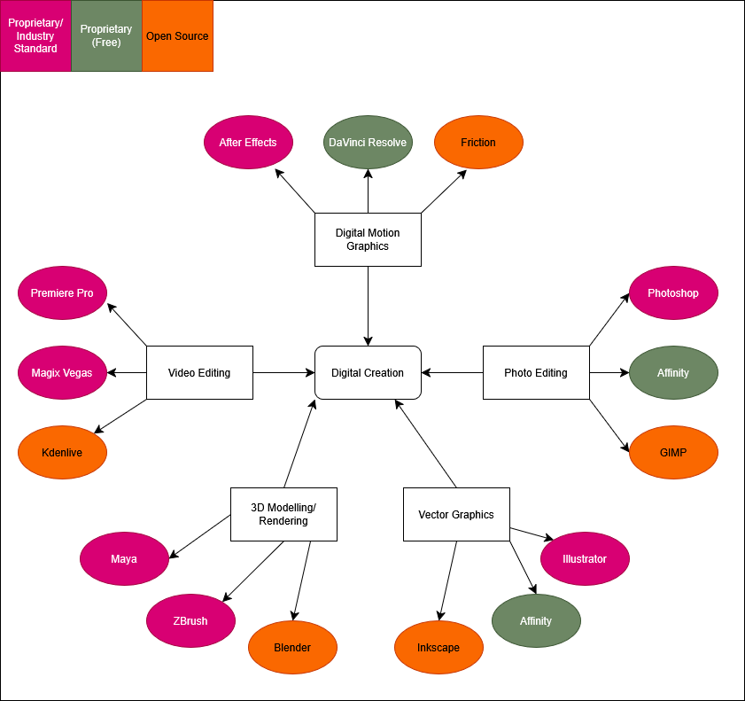
Figure 1: Mapping activity to software use
It is important to understand what open source, proprietary and free mean.

Open Source:
Open source, in relation to software, refers to software where the owner and creator allows others to freely use, inspect, and modify its source code. This encourages open collaboration and community between both users and developers. Open-source software is typically free, but this is not guaranteed. Open-source software is typically created for a multitude of reasons. This includes:
- Fulfilling an untapped niche.
- To provide a lower cost alternative to an existing proprietary program.
- For a developer to practice development with a low-stakes project.
- There are many other reasons for Open-source software to be created, but these are some of the more common origins. Not for profit.
- Open-source does not necessarily mean it is made independently or without a team structure. Two examples of project team structures are detailed by Ben Balter.
- Balter describes the Cathedral and Bazaar people management styles.
- The Cathedral style works top-down using a focused vision and goals, led by a manager. It provides clarity and a sense of stability, but can feel rigid and like a hierarchy. Poor management is felt deeply in this style.
- The Bazaar style works more broadly and without specific, detailed goals. The manager acts like a guide or a coach for the team, rather than a leader. This style promotes innovation and openness, but can lead to confusion and aimlessness if poorly managed.

Proprietary/Industry Standard:

Proprietary software is software that is only available to its creators, typically a company, that is the software’s sole developer and distributor. Proprietary software can also be described as “for profit” software, existing with the intention of selling to a large consumer base.
Proprietary software often takes less risks or experimentation compared to open-source software, and have tightly held licenses and source code that are rarely, if ever, released to the public willingly. Software is made proprietary for various reasons, such as:
- Preventing competing companies from using their source code as a baseline.
- Preventing users from freely modifying and changing code, therefore requiring reliance on the owners.
- Allowing for tightly locked license distribution, making piracy more difficult.
- Making security updates more secure due to a lack of freely available code.
Proprietary software is often developed by much bigger and more experienced teams, with a focused vision in mind. This leads proprietary software to come across more professional and solid compared to open-source software. This comes at a literal cost, as well as the cost of transparency and communal development. Typically, commercial.
A good example of commercial design products is the Adobe suite. Adobe creates and manages a large variety of design programs, some of which this document looks at in more detail.
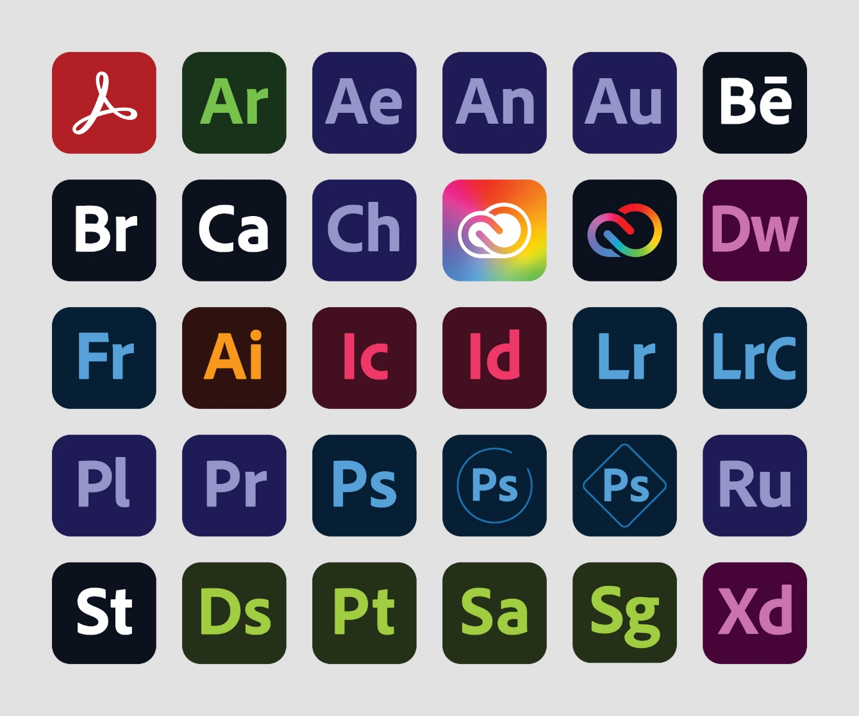
Figure 2: Adobe Product Logos (Proprietary and industry standard)

Proprietary (Free):

Some proprietary software is made free to use by its owners. This is usually done by a corporation who is not making enough profit by putting their product behind a paywall. Corporations must have some alternative way to still make a profit when their products are released for free. This often comes in the form of advertisements built into the program itself. Sometimes it is done when a corporation makes enough of a profit by other means that they can afford to release one of their products for free.
Affinity Photo and Affinity Design, originally a collection of proprietary programs owned by Canva, were combined into one free program earlier this year, whilst this document was being written. A statement from Canva themselves state that they were a stable enough company to release Affinity for free (Hewson, 2025).

Methodology

Choice of Methodology
This document does not use one singular methodology throughout, such as Agile or Waterfall. The reason for this is that design and artistic projects are not as rigid and measurable as a project such as software development. Because of this, each major creation aspect this document covers will use its own methodology, decided on through analysing the most common method used by professionals.

Graphic Design Methodology
This document lays out a 6-step process for the Graphic Design aspect. This methodology is documented by Ihor Kirpichnikov (Kirpichnikov, 2025), and Jessica Barker of Brafton (Barker, 2025).

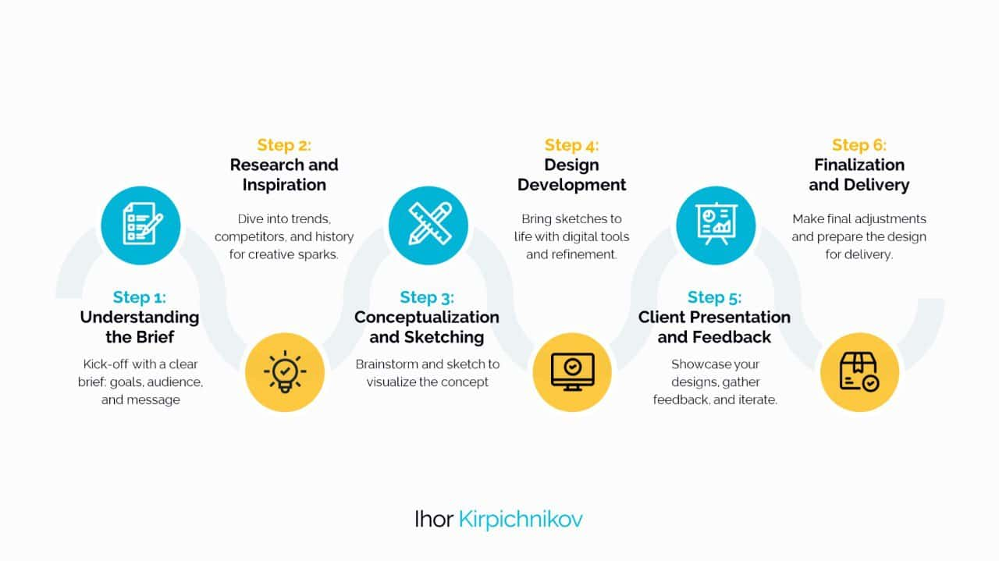
Figure 3 - Graphic Design Methodology (Kirpichnikov, 2025)

The steps are as follows:

Design Brief: Step 1
This step is where the aims of the design are pre-defined. This can involve detailing a design language, what style to achieve, what formats and canvas sizes will be used, what the design is for, etc.
This step is where the basis of the project is laid out.
For example, if designing a CD Cover, you need to consider how large a CD is, how to print the cover onto a real CD, and what style the CD will have.

Research Phase: Step 2
This step involves looking at other designs and research good and bad habits in graphic design. The point of this step is to get a clearer vision of what to achieve with the design, and how to make sure it looks professional and clean.
Since this project involves creating promotional materials, look at other album covers, physical album boxes, various pieces of merchandise, song visualisers. This can allow the designer to see what they do and do not like to have a better understanding for future projects.

Concepts: Step 3
This step involves brainstorming designs. This includes inspirations, colours, emotions, moods, images, layouts.
The ideas and concepts thought up in this step become the basis for the full design. This step is also why it’s best to do the graphic design first, as it will influence the design theming for the rest of the project.
It is here that it is best to have a description of what is it being created, and what the design is meant to invoke in the viewer.

Concept Development: Step 4
This step is where you experiment and plot out the ideas initialised in the previous step. This includes making mock-ups, experimenting with colour palettes, testing fonts, etc.
For example, on a CD cover, decide if the text should go on the sides or on the top or bottom. Look at the colour wheel and what palettes mix well together. This is also a good place to practice using the chosen design programs.

Concept Feedback: Step 5
This step involves showing the conceptualised designs to others to get outside opinions and feedback. This can be done formally through surveys, or informally through word of mouth. This feedback can then be used in the final step.
This can be done through A-B Testing (showing two different designs and asking others to choose which they prefer) or through simple surveys.

Polishing: Step 6
This step is simple. Take the feedback and opinions received in the previous step, and use them to polish and perfect the final designs. These last two steps can be repeated until satisfied with the final product. This step may take the longest time depending the vision and scope of the project.

3D Modelling & Rendering Methodology

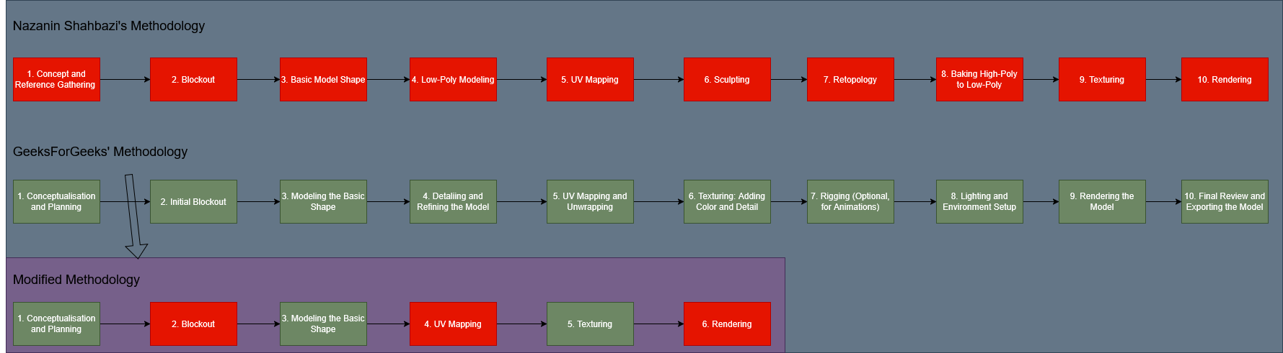
Figure 4 - 3D Modelling Methodology Diagram

This next stage is a 6-step methodology slightly modified from two similar processes laid out by Nazanin Shahbazi of Pixune (Shahbazi, 2024), and GeeksForGeeks (GeeksForGeeks, 2025). These processes contain steps for other 3D sectors, such as games assets and animation, which are not relevant to this project.

Conceptualisation and Planning: Step 1
This is where you determine what the model will be, and its purpose. It is best to look at references and other ideas to get a clearer vision of what to achieve. It is also recommended to draw a concept sketch to look at.
For example, if making a physical CD box for an album, determine how it should be shaped, and what it is being used for. Is it an example to show others or a digitised version of a real object? This is important to determine before starting the model.
Blockout: Step 2
This step is where the modelling itself begins. In this step, use very simple shapes to create the big picture of the model. Stick with cubes, spheres, cylinders and cones for this step.
For example, when making an album box, block out basic thin cuboids. If the box is open, align the cuboids diagonally. You should prioritise the concept of the shape, rather than trying to form it into a more detailed object.

Modelling the Basic Shape: Step 3
In this step, take the blocked out shapes created and refine the proportions and geometry.
For a geometric object like an album box, this step is simple. For example, take the inside of the cuboid and indent it so that objects could fit inside of it, much like a real box.

UV Mapping: Step 4
UV Mapping is the process of taking a 3D model and turning it into a flat 2D object. This is done for the purpose of making sure textures line up with the model correctly.
In the example provided, this would be fairly straightforward. An album box would be made of squares and rectangles of various sizes, so very little work would need to be done.

Texturing: Step 5
The next step is texturing, where a visual identity is given to the model. Various types of texture maps are applied to invoke colours, surface detail, reflections or shine, roughness, patterns, and simulated geometry.
In the album box example, this is the step where you make the box look more like a physical album rather than a generic cuboid shape.

Rendering: Step 6
Rendering is the process of taking the finished model and putting it into a suitable scene, such as under virtual lights with a designated and modified virtual camera. This is done to put the model on display in a way that will appeal to a viewer, making the model itself look more professional and cleaner.
For the album box, this could be done by sitting the box partially open with a strong fill light, to show both the outside and inside of the box and its textures clearly.

Video Production & Rendering Methodology
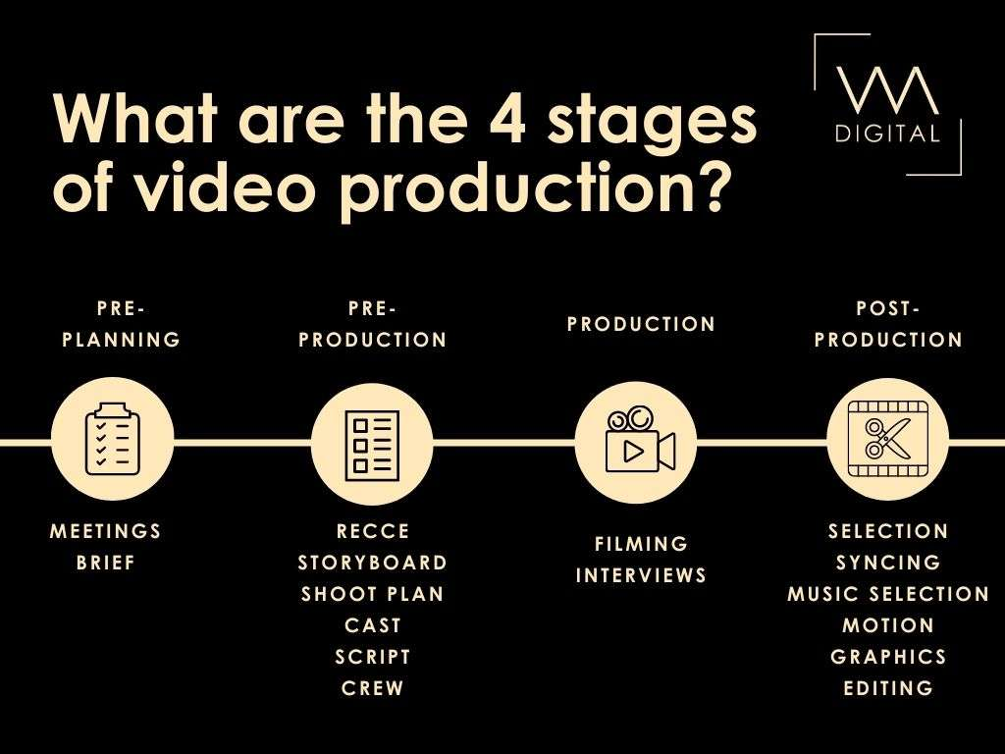
Figure 5 - Video Production Pipeline Diagram [vmdigital, 2021]

This 4-step methodology used for Video Production and Rendering is based off of articles by Fiona Marsh of VMDigital (Marsh, 2021), and Jacob Trussell of Mountain.com (Trussell, 2025).

Pre-Planning: Step 1
This step involves planning and deciding on what the video project will be. This is where the purpose of the video is established, what level of budget is available, whether or not a voice over is required, what the target audience is, what is to be conveyed, and where the video will be released and promoted.
For example, if making a promotional video for a new album, it’s best to include graphics showing the cover of the album and its design. A voice-over might not be necessary, instead a snippet of a track from the album could be used instead. In the case of this project, it’s presumed the budget will be low or even non-existent, and the target audience may be the general public or a particular niche of music listeners.

Pre-Production: Step 2
For a video shot in person, this step would involve getting a cast together, organising shoots, creating a script, and deciding on a site. For a digital video, this step can instead involve gathering assets, making storyboards or animatics, and making a rudimentary version of the final video.
For the example of an album promotion, either method could be used, but for the purpose of sticking to a budget-friendly document, and to keep in line with the previous methodologies, it is presumed the project will be made entirely digitally. It’s best to have a 3D model and album cover design finished by this point to use for any promotional videos.

Production: Step 3
This is where the video itself will be made. For real-life footage, this is the step where the footage itself is recorded and formatted for various screen sizes and social medias. For digitally created footage, this is where the scenes are made, usually in a 3D program and exported as an animated video.
For the album promotion example, a digitally created object and scene can be made in a chosen 3D Modelling and Rendering program, and created using basic animation and camera movements. At this stage of the process, nothing but video footage would be created.

Post-Production: Step 4
This is where the real life and digital footages converge and follow the same process. This step involves taking recorded footage, whether filmed or generated, and putting it into a polished video. Adding text, music, colour grading, cutting and splicing footage, and polishing it into a finished project.
For the Album promotion example, this is where the created renders of the 3D objects would be put into a video editing and/or Digital Motion Graphics software and put together into a finished video.

Development

Design and Development Schedule

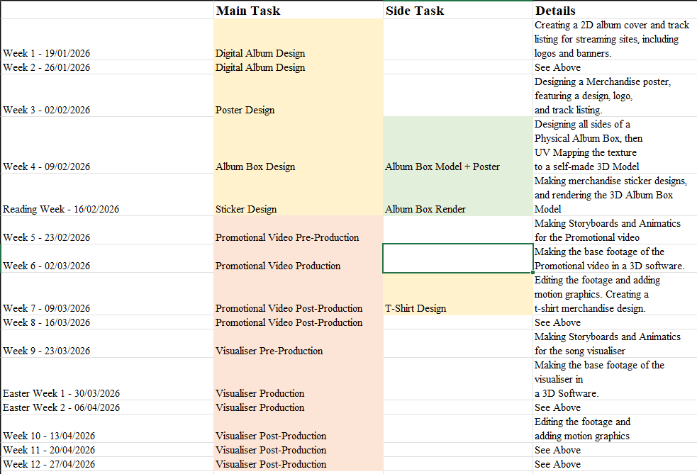
Figure 13 - Production Timeline example
A simple schedule of production for a typical University semester has been created in Microsoft Excel. The 3D Modelling does not begin until after most of the Graphic Design has been done, as the graphic design assets are needed for the 3D Modelling. The same logic is used for the Video Production. More time has been allocated for the Video Production than the other aspects, as this aspect is more time-consuming and difficult.

Tracking Progress
Tracking Progress will be done through an Excel sheet, using a checklist.
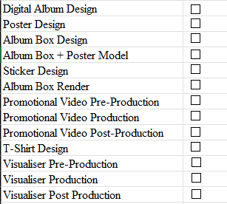

Development:

Week 1:

Weeks 1 and 2 are spent create digital promotional materials for the album. These are used on streaming sites such as Spotify, Apple Music and Soundcloud. This includes a box size cover, a banner, an artist logo, and a track list infographic.

Album Logo (Proprietary):
Make a 5000x5000 Canvas in Affinity. Add a Pixel layer for the background and make a gradient with the following values.
- RGB(18,38,57) at 0% position.
- RGB(46,63,153) at 25% position.
- RGB(107,57,27) at 75% position.
- RGB(184,102,165) at 100% position.
Drag this gradient from bottom right to top left.

Create a text frame across the middle of the canvas, with the font “Engebrechtre”. This font is a free-to-use commercial font, which can be found on the site “DaFont”. Set the font type to Italic. Make the text centred and change the size to 288 points. Align the text box with the centre of the canvas. Change the colour to RGB(178,242,255).
Open Layer Effects for the text layer. Enable Outer Shadow. Use the following settings, and set the colour to RGB(255,15,255).
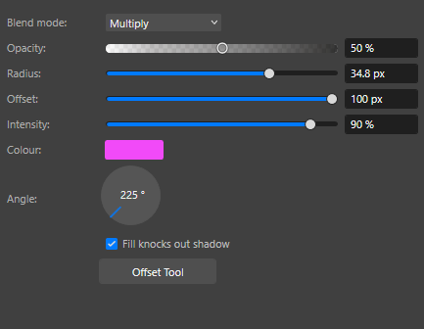
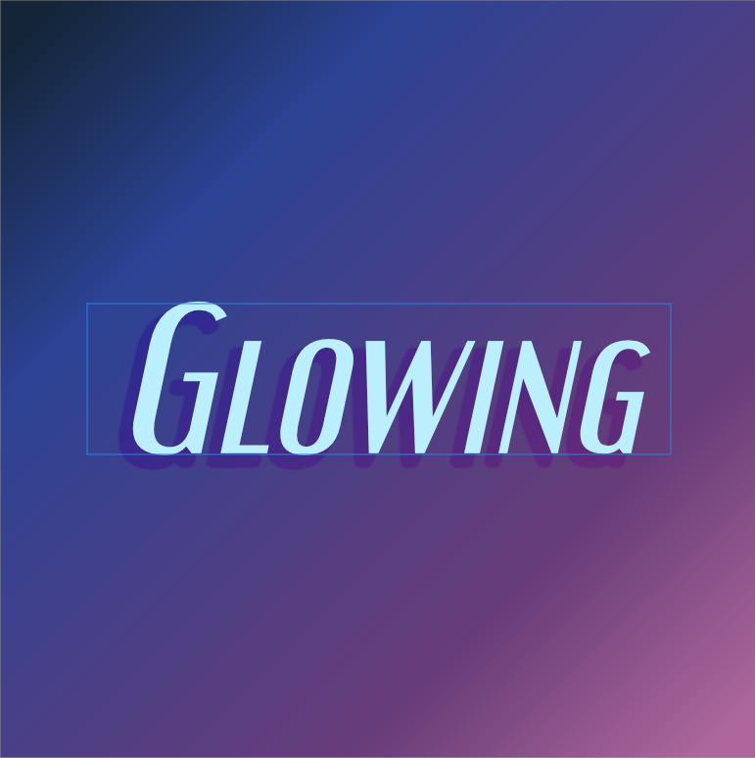
This is the results so far. The blue rectangle is the text box shown by Affinity, and is not a part of the final design.
Duplicate the text layer and move it to the top of the canvas (but do not have the text touching the top). Change the text to the artist name and set the size to 48px. Adjust the text as needed. Go to Layer Effects and disable all effects.
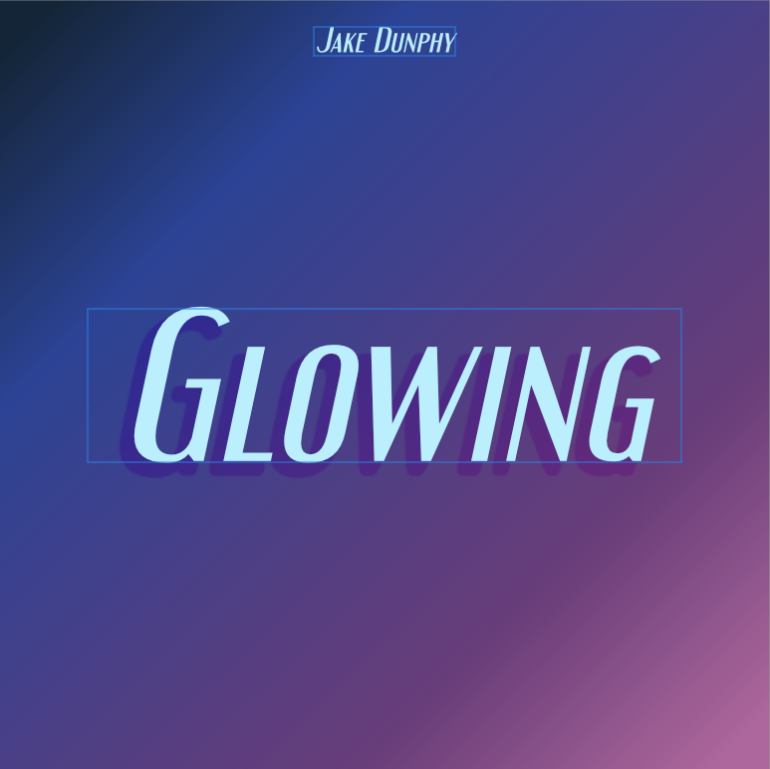
Place a Square Star in the centre of the canvas (while holding shift to keep it proportional), and put the shape layer under the text layers but above the background layer. Give the Square Star a solid colour of RGB(222,185,255). Set the opacity of the layer to 50%.
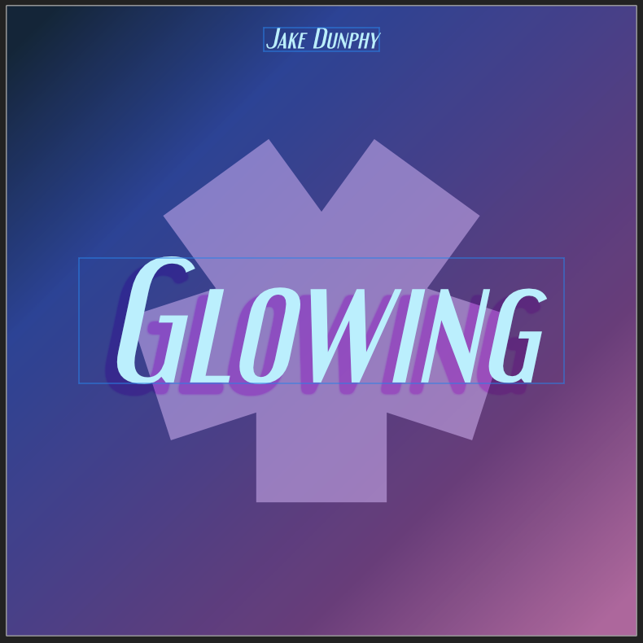
Using layer effects, add an Inner glow to the Square Star with the following settings and colour RGB(216,243,255).
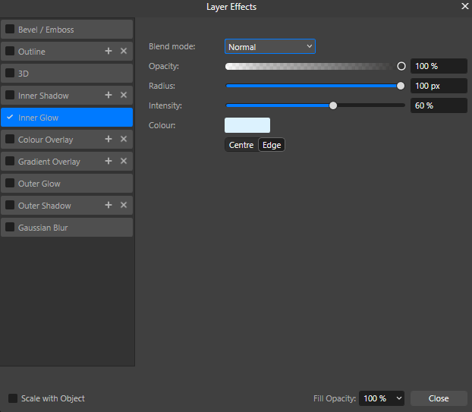
Using Segment shapes, fill the four corners of the canvas with rounded corners, then fill the outer edges of the canvas with rectangles. Take care to make sure there are no gaps between the rectangles and the segment shapes.
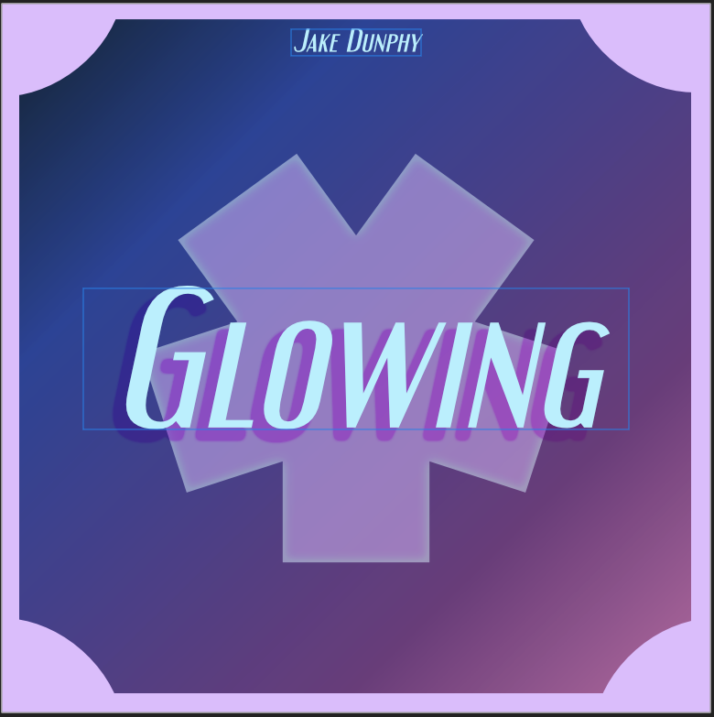

Double click on the edge of a rectangle, and the Mesh Warp tool should appear. Use this to make the centre of each rectangle curve inwards.
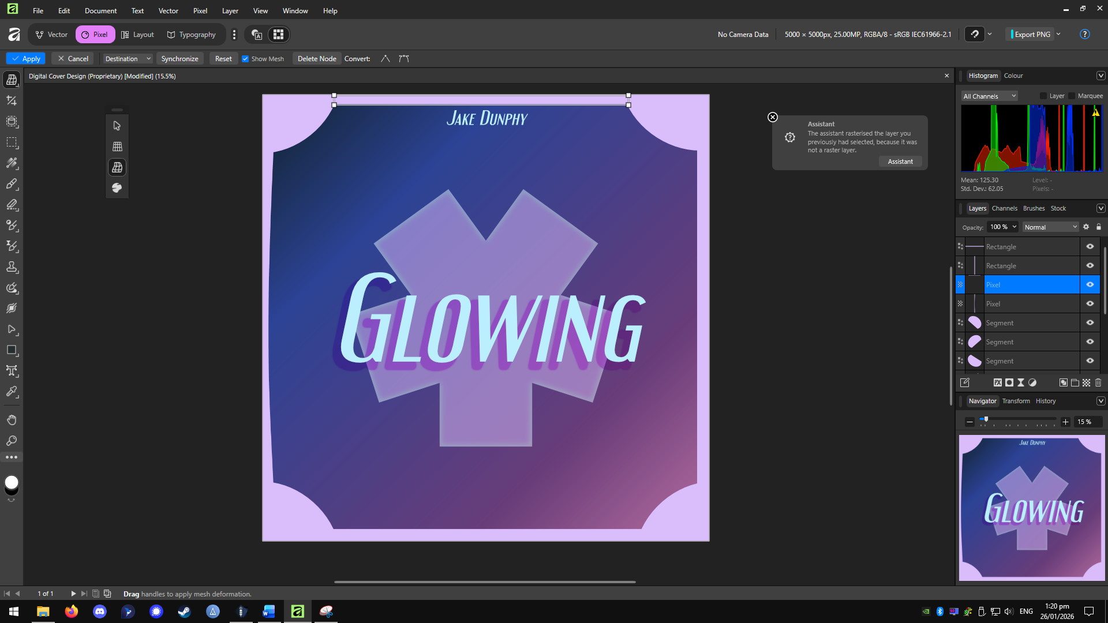
Note: The rectangle shapes must be rasterised to use the warp tool, but Affinity may do this for you.
Keep the curves similar but not identical to give the edges some flow.
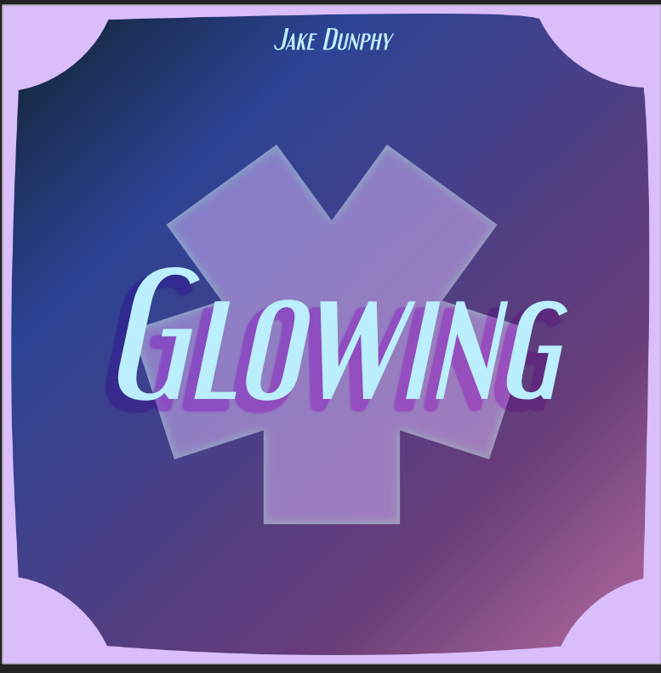
The Digital Album Cover is now complete. The remaining assets will be made using this as a base.

Digital Banner (Proprietary):
Duplicate the file for the Digital Album Cover and open it. Change the canvas dimensions to 2480x520px (these are the recommended dimensions for a Soundcloud banner). This can be done by either pressing CTRL+Shift+P, or by going to Document Setup Document Setup.
The Graphic elements will now be misaligned due to the new canvas size. Start by removing all shapes except for the Square Star, and removing the Artist name, but not the “Glowing” text.
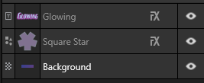
As the text layer is not rasterised, change the text size to 96px before adjusting it to the centre of the canvas, then adjust the square star. (Remember to hold Shift while adjusting the size of the Square Star).
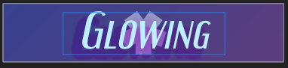
The layer effects were made with a larger canvas in mind, so these must be adjusted.
First, change the outer shadow effect on the Glowing text to the following:
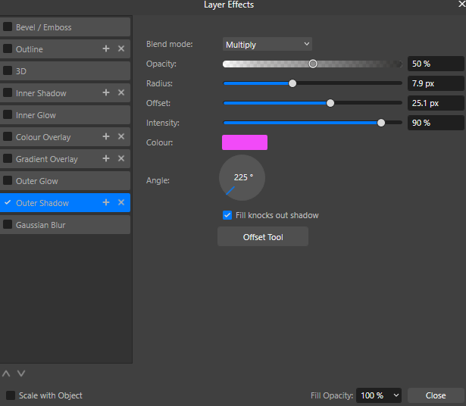
Then change the intensity of the inner glow on the Square Star to 35%.
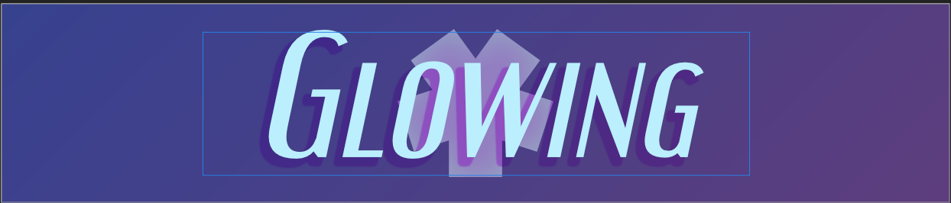
This is the finished banner.

Artist Logo (Proprietary):
Duplicate the Digital Album Design. Remove the “Glowing” text, and the rectangle shapes on the borders. Take the artist’s name text, change the text size to 200 pts, and place it in the centre of the canvas.
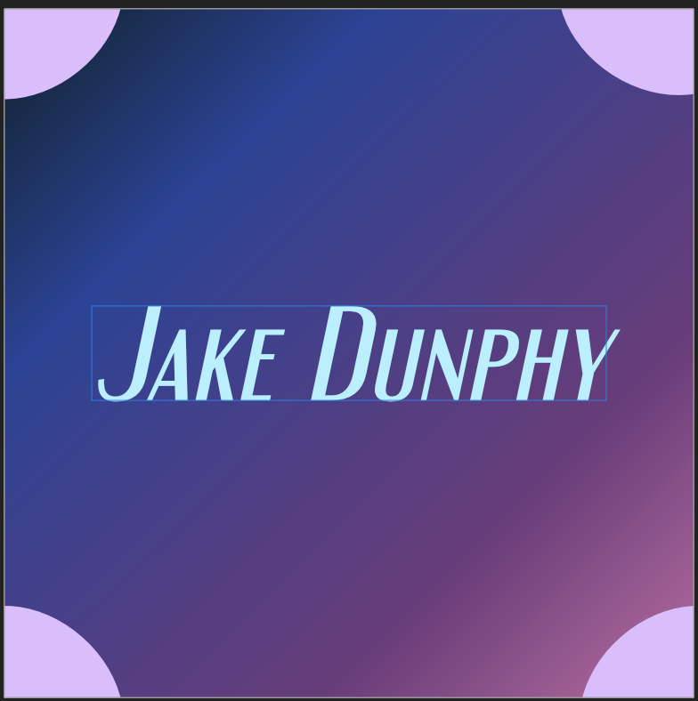
Using Layer Effects, add an Outer glow to the text with the following settings and colour RGB(252,193,255).
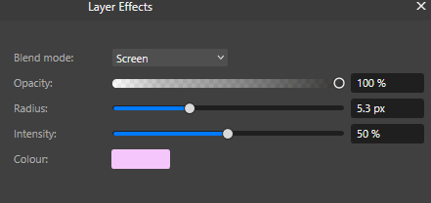

This is the finished artist logo.

Track List (Proprietary):
Duplicate the Digital Album Design. This will be used as the base of the Track List Design.
Go to Document Setup and change the canvas size to a vertical A4 page.
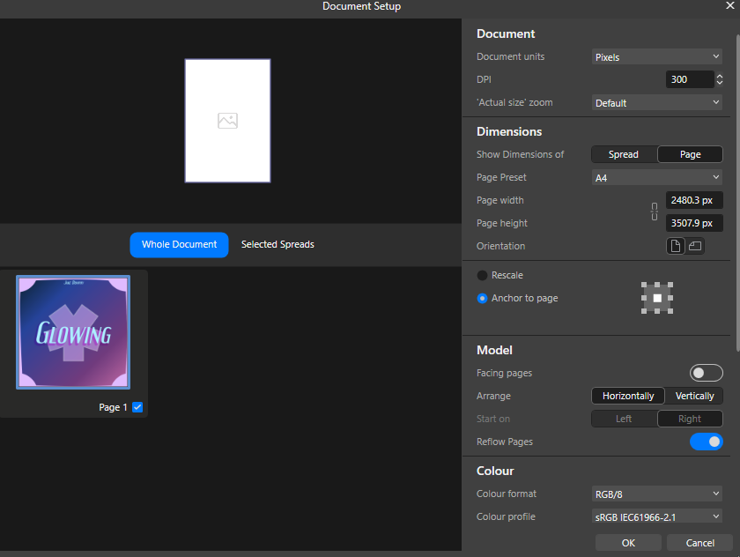
Delete all layers except for the “Glowing” text layer, the Square Star, and the Background layer. Hide the Square Star layer by clicking the eye next to the name. Have the Glowing Text box cover the entire page, leaving margins around the edges of the canvas. Change the text size to 48px, and centre align the text.
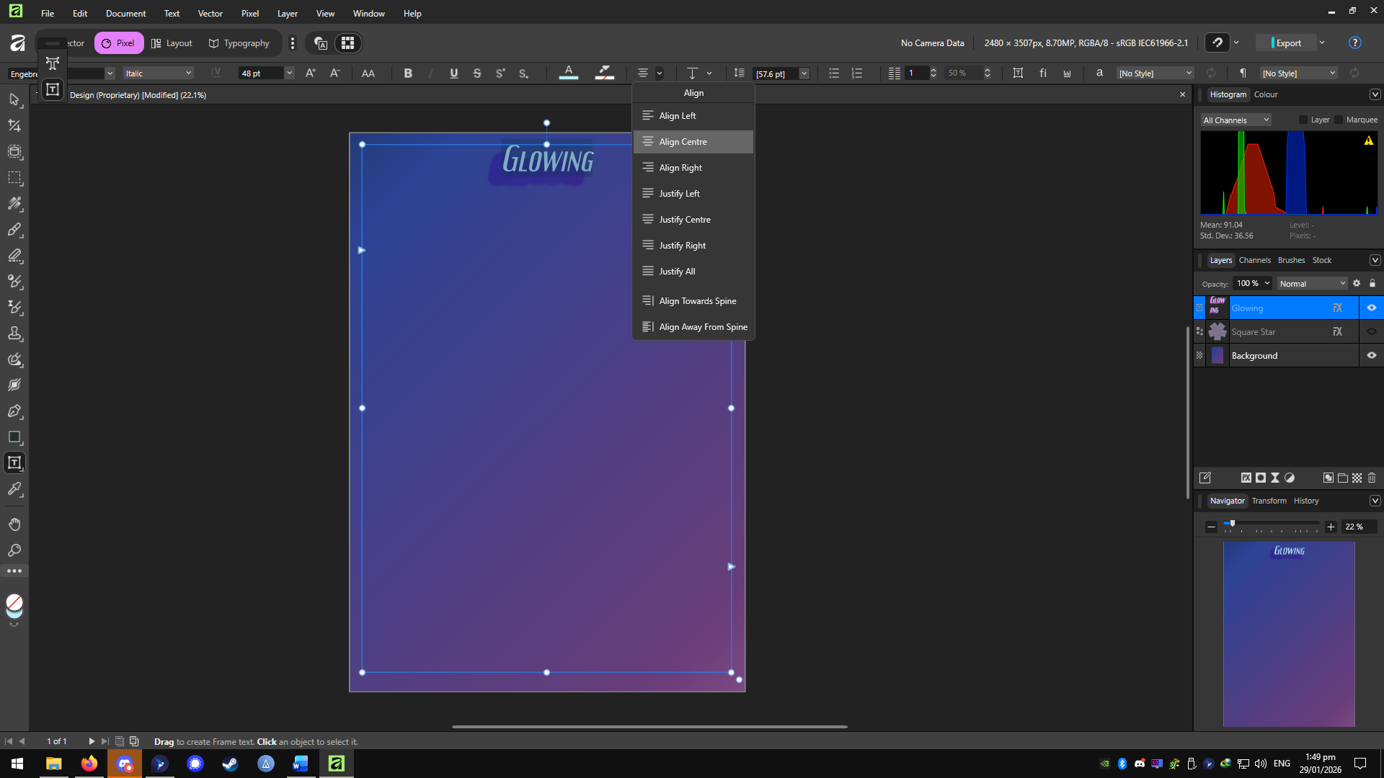
Go to layer effects for the text layer, and remove all Layer effects. Type out the names of the tracks on the album, leaving a new line for each track. Change the line spacing to 72px, and change the size of the “Track List” text at the top to 64px.
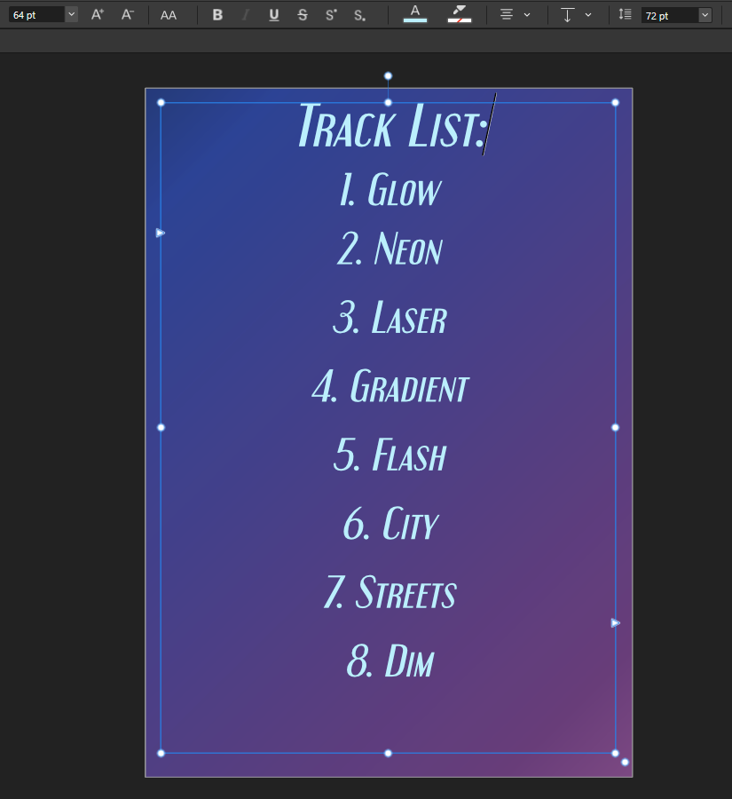
Unhide the Square Star, enlarge it so it is bigger than the size of the canvas, place it exactly in the centre of the canvas, and set the opacity to 15%.
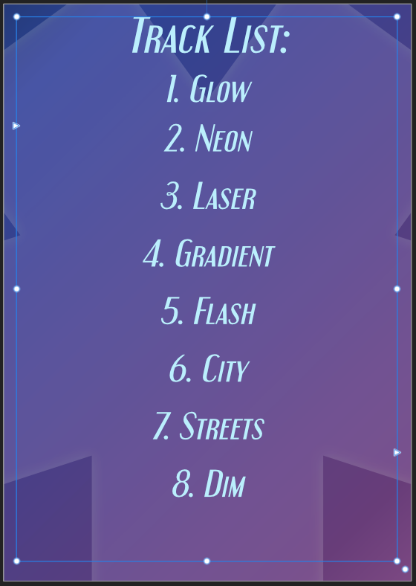
This is the finished Track List.

References
Balter, B. (2023). Cathedral vs Bazaar People Management. [online] Ben Balter. Available at: https://ben.balter.com/2023/12/08/cathedral-bazaar-management/ [Accessed 3 Nov. 2025].
Barker, J. (2021). This 6-Step Graphic Design Process Drives Results (Infographic). [online] Brafton. Available at: https://www.brafton.com/blog/graphics/graphic-design-process/. [Accessed 25 Nov. 25]
Blake, H. (2025). Cost-Benefit Analysis Proprietary Licensing Vs. Open Source Economics. [online] ResearchGate. Available at: https://www.researchgate.net/publication/392557896_Cost-Benefit_Analysis_Proprietary_Licensing_Vs_Open_Source_Economics. [Accessed 18th Nov 2025]

Jepsen, C.R., Berger, P. 2023. Kollage. Carly Rae Jepsen. The Loveliest Time. [Digital Audio]. United States: 604, Schoolboy, Interscope Records.
GeeksforGeeks (2025). 3D Modeling Process: A Step by Step Guide. [online] GeeksforGeeks. Available at: https://www.geeksforgeeks.org/blogs/3d-modeling-process-steps/. [Accessed 25 Nov. 25]
Grupo Erik Editores S.L. (2025). Europosters.ie [online] Available at: https://www.europosters.ie/posters/aespa-supernova-v184428 [Accessed 8 Dec. 25]
Hewson, A. (2025). Introducing the all-new Affinity: Professional design, now free for everyone. [online] Available at: https://www.canva.com/newsroom/news/all-new-affinity/. [Accessed 2 Dec. 25]
Hoffmann, M., Nagle, F. and Zhou, Y. (2024). The Value of Open Source Software. SSRN Electronic Journal. [online] https://doi.org/10.2139/ssrn.4693148. [Accessed 18th Nov 2025]
HYBE LABELS (2025). LE SSERAFIM (르세라핌) 'DIFFERENT (English ver.)' Official Visualizer. Available at: https://youtu.be/NezdSLx4O7w [Accessed 8 Dec. 25].
JYP Entertainment (2025). NMIXX(엔믹스) “Blue Valentine” Trailer: The Paradox of Love. Available at: https://youtu.be/QSvlQxjnQaQ [Accessed 8 Dec. 2025].
Kirpichnikov, I. (2024). 6-step Graphic Design Process: From Concept to Completion. [online] The best of AI and online business in one place. Available at: https://www.ikagency.com/graphic-design-typography/graphic-design-process/. [Accessed 25 Nov. 25]
Koreaboo. (2017). Koreaboo. [online] Available at: https://www.koreaboo.com/stories/11-kpop-albums-best-packaging/ [Accessed 2 Dec. 2025].
Marsh, F. (2021). What are the 4 stages of video production - VM Digital. [online] Available at: https://vmdigital.ie/stages-of-video-production/. [Accessed 2 Dec. 25]
Pragunagarwal.com. (2025). Filament — Pragun Agarwal — Portfolio. [online] Available at: https://pragunagarwal.com/Filament [Accessed 2 Dec. 25].
Sennett, R. (2008). The Craftsman. Penguin UK.
Shahbazi, N. (2024). 10 Main Steps in 3D Modeling Process. [online] Available at: https://pixune.com/blog/3d-modeling-process/. [Accessed 25 Nov. 25]
tasty design (2025). Music T-shirt design. Music t-shirt design vector. For t-shirt print and other uses. [online] Vecteezy. Available at: https://www.vecteezy.com/vector-art/11426982-music-t-shirt-design-music-t-shirt-design-vector-for-t-shirt-print-and-other-uses [Accessed 8 Dec. 2025].
Trussell, J. (2025). Video Production Process: Complete Guide for 2025 - QuickFrame. [online] QuickFrame. Available at: https://quickframe.mountain.com/blog/video-production-process/. [Accessed 2 Dec. 25]
University, D. of I.T.H., Ave, 400 S.O., South Orange, N. 07079 and (973) 275-2222 (n.d.). Adobe Creative Campus - Seton Hall University. [online] www.shu.edu. Available at: https://www.shu.edu/technology/adobe.html. [Accessed 18th Nov 2025]
Vasconcellos, R. (2007). Wikimedia. [online] Available at: https://commons.wikimedia.org/wiki/File:Jewel_Case_02.jpg [Accessed 8 Dec. 2025].
Wikipedia. (2021). Optical disc packaging. [online] Available at: https://en.wikipedia.org/wiki/Optical_disc_packaging. [Accessed 2 Dec. 25]

‌

‌

